A mathematical model for a disease that confers immunity after infection: An SIR model*

Consider a disease that confers resistance to re-infection once the disease has run its course.

At any given time in the population, each individual is one of the following:

- Susceptible: they don’t yet have disease
- Infectious: they are infectious and capable of passing infection to others
- Resistant: they are recovered and resistant to further infection

S
I
R

This is an example of a compartment (or state) model. In this model, there are 3 compartments, and individuals can move in one direction from compartment to compartment.
Assumptions to allow us to formulate a simple model:

- Population is fixed – no birth, no death, immigration, emigration

- Latent period is zero

- Duration of infectivity is the same as duration of clinical disease

- The disease is first introduced to the population by a single person

Before the outsider arrives, everyone is in the susceptible group.

What do think will happen to the proportion of individuals in each compartment or state if R₀ > 1? If R₀ < 1?

We can describe the flow of individuals through the different compartments between time points using the same parameters that define R₀.

Assume a fixed interval between the times that we count individuals in each state so that we have a discrete SIR model.

Let S_{t} be the number of individuals in the susceptible state at time t. For instance, for a population of 1000, S₁ = 1000.

I_{t} = number in the infectious state at time t (I₁ = 0)

R_{t} the number in the resistant state at time t (R₁ = 0).

Moving from susceptible (S) to infectious (I)

S_{t+1}= S_{t} – β * κ * I _{t}* (S _{t} ÷ Number of individuals in population)

The number of individuals that move from susceptible to infectious between time points depends on several factors.

Consider β * κ.

Example: In a preschool, on average, each child has contact with 20 other preschoolers per day. If the probability of transmission of pink eye is .80 per contact, how may contacts with one infectious child have the potential to be infectious?

Why do we multiply by I next?

Example: In the same preschool, assume we have 2 children with pink eye. How may contacts per day include an infectious child and have the potential to be infectious?

In the population, there are 6 different types of contacts that can occur:

Susceptible/Susceptible Susceptible/Infectious

Susceptible/Resistant Infectious/Infectious

Infectious/Resistant Resistant/Resistant

Which ones result in a transmission that moves a susceptible person into the infectious state?

Why do we multiply by proportion of susceptible individuals?

Example: In the same preschool, assume we have 2 children with pink eye and 198 susceptible. How may contacts per day will result in the transmission of pink eye from one of the two infected kids to one of the susceptibles?

After one day, we have 2 + preschoolers with pink eye.

Moving from susceptible (S) to infectious (I)

I_{t+1}= I_{t} + β * κ * I _{t}* (S _{t} ÷# individuals in population) –

Where did the β * κ * I _{t}* (S _{t} ÷# individuals in population) part come from?

Why do people move out of the infectious state?

Example: If the duration of pink eye is 7 days, how many children recover between day 2 and day 3 (say had 34 infected kids on day 2)?

Moving from infectious to resistant (R):

R_{t+1}= R_{t} +

Activity: Calculate S₂, I₂, R₂ and S₃, I₃, R₃ if S₁ = .66, I₁ = .165, and R₁ = .175 for β=.60, κ=2 per day, and D=2 days.

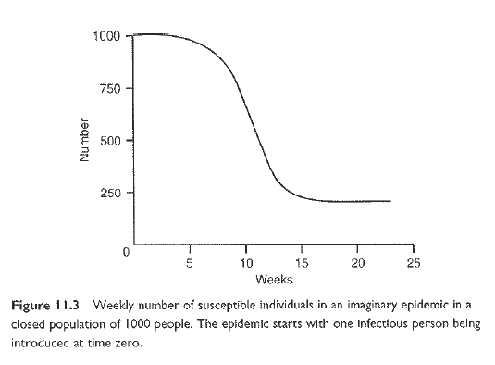
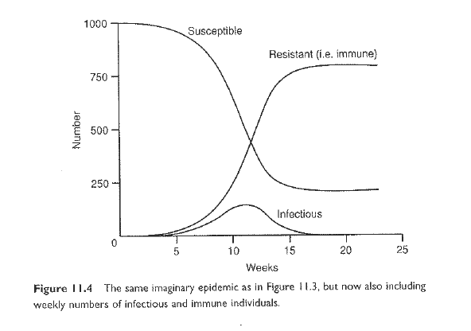
Making our SIR model more complicated

Material from: Chapter 11, Mathematical models for epidemics in Modern Disease Epidemiology by Johan Giesecke (2002).

References:

* Kermack and McKendrick (1927)
Modeling an Infectious Disease Epidemic: SIS Model and Markov Chain Formulation
Thursday July 20, 2006: Morning session

SIS model: a model for a disease that does not confer immunity after infection

The SIR model we used yesterday can be modified in a simple way in the case that the illness does not confer immunity.

The model is called an SIS model since we assume that individuals return to the Susceptible state after infection.

At any given time in the population, each individual is one of the following:

- Susceptible: they don’t have disease (but may have had it before)
- Infectious: they are infectious and capable of passing infection to others

S
I

Assumptions:

- Population is fixed – no birth, no death, immigration, emigration
- Latent period is zero
- Duration of infectivity is the same as duration of clinical disease
- The disease is first introduced to the population by a single person
- Individuals return to the Susceptible state at the end of the infectious period

Recall the system of equations for the SIR model:

S_{t+1}= S_{t} - β * κ * s _{t}* I _{t}

I_{t+1}= I_{t} + β x κ x s _{t} x I _{t} –

R_{t+1}= R_{t} +

We no longer need the equation for transition from I to R.

How should the equations for S_{t+1} and be I_{t+1} changed?

S_{t+1}= S_{t} - β * κ * s _{t}* I _{t} +

I_{t+1}= I_{t} + β x κ x s _{t} x I _{t} –

Markov chain formulation of model

Recall that a Markov chain is a sequence of state matrices, where (for a 1st order chain), the current state matrix depends only on the matrix just before the current one and the transition matrix that describes the probability of moving from one state to the other.

Note that we have a finite set of states (S and I) and that we can set up a sequence of state matrices for the population. Let’s use our example of a population with 1000 individuals, one of whom just came in from the outside and introduced infection.

The state matrices will all have the form:

[proportion of population in S proportion of population in I]

The first state matrix = [999/1000 1/1000] = [.999 .001].

We also have a set of probabilities for moving between S and I.

The transition matrix has the following form:

What is the probability of moving from state S to state I?

What is the probability of moving from state I to state S?

What is the probability of staying in state S?

What is the probability of staying in state I?

The first transition matrix is (FIX!!!!!!!!!!):

Use the first state matrix and the transition matrix to find the second state matrix.

Homework:

Try to find a model with steady state other than all infected individuals zero for SIR. What is the

Go through birth/death problem based on Troy Tassier.

